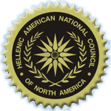  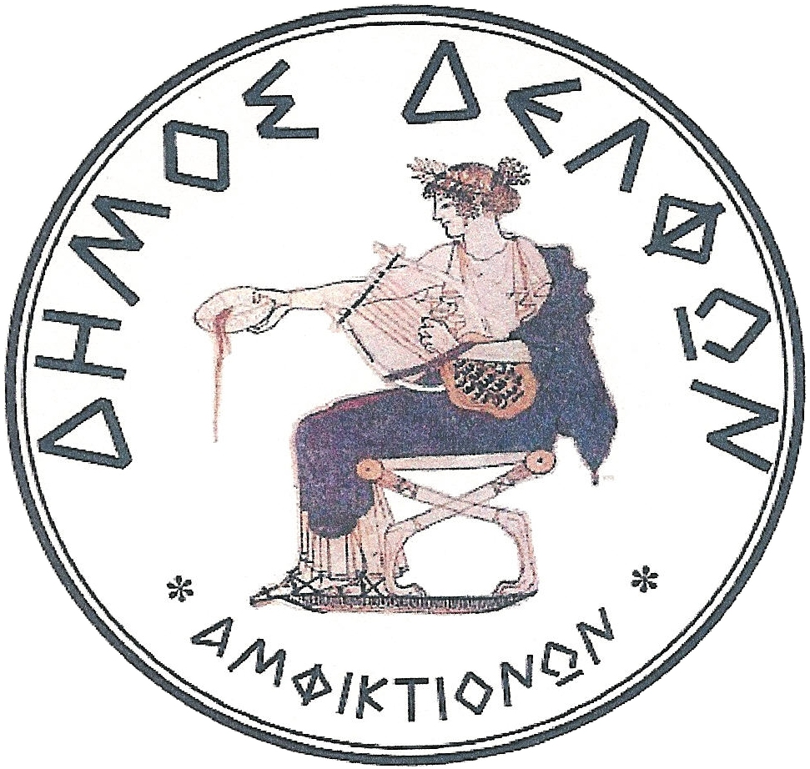 | Hellenic American National Council  www.hancusa.net  Municipality of Delphi  17th Annual Convention of H.A.N.C.  &  1st International Symposium  “Reviving the Delphic Idea”  “Know Thyself”  Delphi – Greece  August 17, 18, 19 & 20, 2006
August 17th, Thursday
PROGRAM DETAILS STILL IN DEVELOPMENT

Arrival- Check in Hotels
Convention, Symposium & Events Registration

Delphi Palace
20:30 – Cocktail Hour
21:30 - Welcome Dinner
August 18th, Friday

09:00 a.m. : “APOLLO” Amphitheatre
H.A.N.C.’s Convention Opening
Greetings:
-Mayor of Delphi, Mr. Panagiotis Kaltsis
-Director of the European Cultural Centre of Delphi, Christodoulos Giallouridis
-Deputy Minister of Foreign Affairs, Th. Kassimis
-Representatives of the political parties of the Greek Parliament
-Representatives of the Special Permanent Committee for Greeks Abroad of the
Greek Parliament
-Secretary General of The Ministry of National Education and Religious Affairs
A. Karamanos
-Nick Fousekis, President of the Union of Municipalities and Communities
-Ioannis Bougas, Member of the Greek Parliament
-Panos Liatsos, Representative of AHEPA Hellas
-President of the Hellenic American National Council

-Report of the President of the Hellenic American National Council /
Reports of the Presidents of the Federations - Members of H.A.N.C.
Open Discussion:
▪National Issues
Panos Spiliakos, President of Pan-Macedonian Association
“The Greek American Lobby”
▪Hellenic American Youth: “Passing the Torch”
Emmanuel E. Velivasakis, 1st Vice President of H.A.N.C.
Pan-Cretan Association of America, President
▪Hellenic Synergy:
Hellenes Abroad and Greek Authorities
Cooperation and Coordination: Setting common goals and agendas
Coffee Break
Hellenic Education Abroad
•Ismini Kriari-Katrani, State Secretary for Greek Studies Abroad and
Intercultural Education Greek Ministry of National Education and Religious
Affairs
“The Perspectives of Hellenic-Language Paideia Abroad”
• Georgia Xanthaki-Karamanou, Professor, University of Athens,
Department of Philology and President of the Association of Greek
Philologists
“The Reception of Greek in English”
•Stella Kokolis, President of the Pan-Hellenic American Educators
Federation
•Terry Tsafatinos, President of Plato School
“The Greek –American Charter Schools”
• Dimitris Bratis, President of Greek Primary Teachers Federation, DOE
• George Reganis, President of Federation of Sterea Hellas of America and
Canada
“A strategic proposal for the primary education in U.S.A.”
Educators United:
The Affiliation Pan-Hellenic American Educators Federation” – Greek Primary Teachers Federation

14:00 p.m. – Lunch
3:30 p.m.
▪Dinos Routzounis, President of Kapa Research Group
Presentation: The Research on Hellenism Abroad by Kapa Research and
Harvard University
▪Dr. Zagkas Theocharis, Associate Professor, Forestry and Natural Environment
«The Natural Environment of Greece from Ancient Times until Today”

Common Roots Partners:
The Affiliation of Plant your Roots in Greece – The Friends of Green
Coffee Break
•Interventions
•Conclusions – Resolutions:
19:30 p.m. Dinner
21:15 p.m. Theater “Frynihos”
“The Frogs of Aristophanes” by Attic Stage
With Anna Synodinou and Harry Roma

August 19^{th,} Saturday

1st INTERNATIONAL SYMPOSIUM
“Reviving the Delphic Idea”
Co-organized by Hellenic American National Council
&
The Municipality of Delphi

“Know Thyself”
PROGRAM DETAILS STILL IN DEVELOPMENT
9:00 a.m.
●“Reviving the Delphic Idea” & “Know Thyself: the Source of Humanitarian Acts”
Introduction by the President of H.A.N.C. Mr. Theodore Spyropoulos and the Mayor of Delphi Mr. Panagiotis Kaltsis

Symposia: Aspects of the Delphic Idea

Speakers:
9:30 a.m. - 10:30 a.m.
● Dr. Gail Mellow, President of LaGuardia Community College
“What Might the Oracle Say? Higher Education and the Delphic Ideal in a Profoundly Connected World”.
In this presentation, followed by a question and answer period, Dr. Mellow will outline the conundrum of colleges and universities across the globe as they attempt to frame a curriculum and a pedagogy for the Knowledge Era. Using the dictums of the ancient oracles of Delphi as a frame, the talk will explore the ways in which globalization, mobility and technology challenge educational leaders to find new methods to teach an increasingly international student population to achieve sophrosyne- the ideal of multiple kinds of wisdom held in human balance.

10:30 a.m. – 11:00 a.m.
● Dr. Bruce Thornton, Professor of Classics and Humanities, California State University, Fresno, California
“Critical Consciousness and the Greek Achievement”
Synopsis: When asked to define the achievement of the Greeks, we usually list the intellectual, artistic, and political equipment we have inherited from them: philosophy, history, logic, physics, criticism, rhetoric, dialectic, dialogue, tragedy, comedy, epic, lyric, aesthetics, analysis, democracy--these are all Greek words. Taken together they constitute the cultural and mental foundations of Western civilization. Yet such a list perhaps obscures a more interesting question: What is it in the ancient Greek mind that provides the common denominator of all these words? The answer is that they are all the formalized expressions of the essence of the Greek achievement: critical consciousness. This is the impulse and willingness to stand back from humanity and nature and even the gods, to make them objects of thought and criticism, and to search for their meaning and significance-- "to see life steadily, and see it whole," as Matthew Arnold put it, instead of remaining enslaved to custom, tradition, superstition, nature, or the brute force of political or priestly elites.
11:00 a.m. – 11:30 a.m.
● Emmanuel Mikroyiannakis, Professor of Ancient History, Athens University's School of Philosophy
΄”The meaning and the importance of Amphictyonies”

11:30 a.m. Coffee break

12:00 a.m. -12:20 p.m.
●Anna Efstathiou Tziropoulou, Philologist, Author- Professor of Historical Greek Literature, Alpine University, Zurich
“Know Thyself: The Anatomy of the Soul Revealed through the Greek language”

12:20 p.m. – 12:40 p.m.
●Dr. Christos Evangeliou, Professor of Philosophy, Department of Philosophy,
Towson University
“Socrates as Teacher of Virtue”

12:40 p.m. -13:00 p.m.
●Dr. Evaggelos Vallianatos
“Why Greece must have a Renaissance”

13:00 p.m. – Lunch

16:00 p.m. -16:30 p.m.
●Kostas Spyropoulos, General Manager of E.R.T.
“Documenting Oral History”
Oral history is a new stream: It records people's experiences on sound and video tape. It is a vital tool for our understanding of the recent past. No longer are we dependent only on the written word.

16:30 p.m. -16:45 p.m.
●Evan Fotis, Physiognomist, Artist and cartoonist
“The Facial Oracle: Human knowledge and Communication”

16:45 p.m. -17:45 p.m.

The Universalism of the Greek Civilization and Language

●Dr. Ing. Stavros Dorikos
“The Big Continent (contemporary America) and Ancient Greece”
Historical and linguistic approach

●Dr. Eng. Kostas Chatziyiannakis
Universal Elements of the Greek Language

●Dr. Nors S. Josephson, Professor of Linguistics, University of Heidelberg
“Easter Island: The Greek Naval of the Earth”
Synopsis: The language and culture of Easter Island can be traced back in part to archaic Greek origins of the sixth century B.C. In addition to about one thousand and sixty word roots of Greek origin that appear in the language of Easter Island and related Polynesian idioms, we also encounter numerous grammatical forms (such as noun and verbal endings) in these languages that possess ancient Greek origins.
Moreover, the megalithic stone constructions (including temples and statues) of Easter Island and eastern Polynesia also utilize ancient Egyptian and Greek metrical units –such as 33.3 cm and 52.3 cm. Also, the older traditional music and other cultural trademarks of Easter Island (such as clothing articles) can be traced back to older archaic Greek prototypes. Finally, the written scripts (including mama and rongo-rongo) of Easter Island use elements of the older Egyptian (hieroglyphic), Cretan and Cypriot writing systems.

17:45 p.m. Coffee Break

18:00 p.m. – 19:00 p.m.
Interventions – Open Discussion- Conclusions

19:45 p.m. Cocktail – Buffet

21:00 p.m. Theater “Frynihos”
The bestowal of the “Golden Lyre of Apollo” Award to the unique Composer Vangelis for his contribution, through his music and public expression, to the promotion and the dissemination of the ecumenical and universal Values of Hellenism by the Mayor of the Municipality of Delphi and the president of the Hellenic American National Council.
Presentation of Mythodia

23:00 p.m. Gala
August 20th, Sunday

09:00 a.m. Visit to the Exhibition of Greek Political Cartoons
09:30 a.m.- 10:15 p.m.
Tour of the Angelos and Eva Sikelianos Museum
(The poet, Angelos Sikelianos and his American born wife Eva Palmer-Sikelianos were the pioneers in the revival of the Delphic Idea)
Proclamation Declaring Th. Spyropoulos an Honorary Citizen of Delphi
10:30 p.m. -12:00 p.m.: A Tour of the Sacred Land of Apollo
12:00 p.m. – 13;00 p.m. Sanctuary of Athena Pronaia
•Reading of the Delphian Declaration –Conclusion of the Symposium

13:45 p.m. Picnic (traditional spit-roasted lamb) under the firs of Parnassos
Live music- cultural events
•Return to Delphi

18:00 p.m.
Dynamic Humanism:
Partnership of the Delphi Ecumenical Union and the US Regional Council of Hellenic Education (R.C.H.E.)

