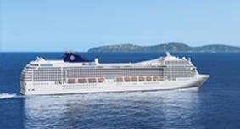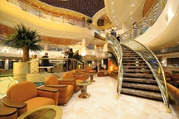

OPA! Let the fun begin for 2012!
Join other Americans, Greeks, Friends and Family on our
6th Annual OPA Greek Cultural Cruise
Sailing on a new cruise line - MSC Cruises “Poesia”
Saturday February 11 – 18, 2012 from Fort Lauderdale, FL
Prices start at only $579 per person
RATES* | EARLY Booking |  | Effective MAY 1
RATES* | Pricing |  | PRICING
Inside |  |  |  |  |  |  | Itinerary
1 | 579 |  | 629 |  | Day |  | Port | Arrival | Departure
2 | 619 |  | 669 |  | 1 | SAT | Ft. Lauderdale |  | 7:00PM
3 | 669 |  | 719 |  | 2 | SUN | Key West, Florida | 7:00am | 2:00pm
Oceanview |  |  |  |  | 3 | MON | Cozumel, Mexico | 10:00am | 6:00pm
5 Obstr | 739 |  | 789 |  | 4 | TUE | Isla de Roatan, Honduras | 10:00am | 6:00pm
4 | 789 |  | 839 |  | 5 | WED | At Sea
Standard Balcony |  |  |  |  | 6 | THU | Montego Bay, Jamaica | 8:00am | 3:00pm
6 | 939 |  | 989 |  | 7 | FRI | at Sea
7 | 959 |  | 1009 |  | 8 | SAT | Ft. Lauderdale | 8:00am
8 | 979 |  | 1029 |  | REDUCED DEPOSIT OF $100 PER PERSON IS APPLICABLE
Superior Balcony |  |  |  |  | IF BOOKED PRIOR TO MAY 1, 2011 - REFUNDABLE UNTIL OCT. 1, 2011
9 | 1019 |  | 1069 |  | *Prices are per person, double occupancy and include cruise,
10 | 1049 |  | 1099 |  | port charges, taxes and entry to all private Greek parties
11 | 1079 |  | 1129 |  | and events. Rates and information subject to change without notice.
Suite |  |  |  |  | Please note: Only passengers booking with TravelGroup will be eligible
12 | 1319 |  | 1369 |  | to attend all Greek activities.
Sponsored by the Greek Orthodox Mission of Ocala

